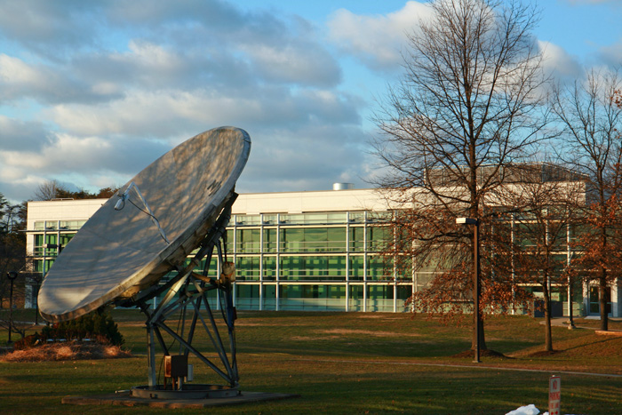

**WHAT TO EXPECT:**

* *Capitol Cyber Challenge -* The camp features a variety of exciting. informative activities, including scavenger hunts and other cyber games; training in computer forensics; coding and scripting with Python and other languages; creating software robots; and working with 3D printers. Perfect both for students who are interested in cybersecurity but don't know much about it, and also for those who have had some cybersecurity experience during high school and want to increase their knowledge base.
* *Coding Camp -* Students will learn the basics of networking along with the practical use of infrastructure devices such as switches and routers. They will configure those devices using CISCO’s Line Interface (CLI). Topics that will be covered include: TCP/IP, IP Addressing, Switching Devices IOS and Commands, Routing Protocols such as RIP, OSPF and EIGRP, & Firewalls via ACL.

**Cyber Summer Camps at Capitol Registration Form***Please email this completed registration form to: Cybersat@captechu.edu*

**Name: School:**

**Age: Email:**

**City: State: Phone:**

**Which Cyber camp/s would you like to attend?**

Payment options:

Credit Card : _____Visa ______Discover ______MasterCard ________American Express

Credit Card # _________________________________ Expiration Date: ____________________________________

Cardholder Name ____________________________ ___ Signature _________________________________________

Card billing address (if different from student address)

_____________________________________________________________________

**Dates:**

Capitol Cyber Challenge - July 10-July 14

Coding Camp- July 31-August 1

Both camps run from 9:00a-4:00p

**Where:** Capitol Technology University, 11301 Springfield Rd. Laurel, MD 20708

**Cost:** $350 per camp

**Cyber Summer Camps**